A confusion matrix is a table that is often used to **describe the performance of a classification model** (or "classifier") on a set of test data for which the true values are known.

Let's start with an **example confusion matrix for a binary classifier** (though it can easily be extended to the case of more than two classes):

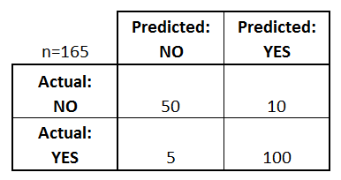

I've added these terms to the **confusion matrix**, and also added the row and column totals:

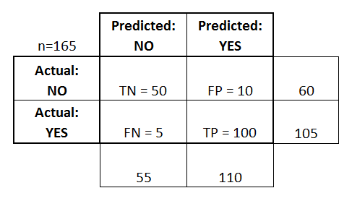

This is a list of rates that are often computed from a confusion matrix for a binary classifier:

* **Accuracy:** Overall, how often is the classifier correct?
* 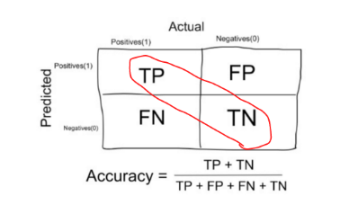
  + (TP+TN)/total = (100+50)/165 = 0.91
* **Misclassification Rate:** Overall, how often is it wrong?
  + (FP+FN)/total = (10+5)/165 = 0.09
  + equivalent to 1 minus Accuracy
  + also known as "Error Rate"
* **True Positive Rate:** When it's actually yes, how often does it predict yes?
* 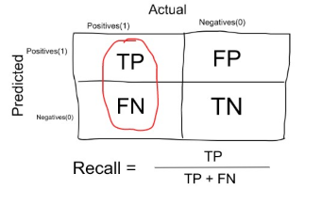
  + TP/actual yes = 100/105 = 0.95
  + also known as "Sensitivity" or "Recall"
* **False Positive Rate:** When it's actually no, how often does it predict yes?
  + FP/actual no = 10/60 = 0.17
* **True Negative Rate:** When it's actually no, how often does it predict no?
* 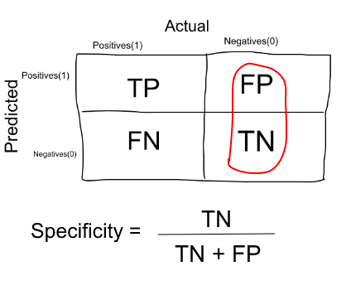
  + TN/actual no = 50/60 = 0.83
  + equivalent to 1 minus False Positive Rate
  + also known as "Specificity"
* **Precision:** When it predicts yes, how often is it correct?
* 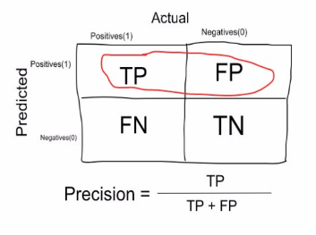
  + TP/predicted yes = 100/110 = 0.91
* **Prevalence:** How often does the yes condition actually occur in our sample?
  + actual yes/total = 105/165 = 0.64
* **F Score:** This is a weighted average of the true positive rate (recall) and precision.
* F1 Score = 2 * Precision * Recall / (Precision + Recall)
* **ROC Curve:** This is a commonly used graph that summarizes the performance of a classifier over all possible thresholds. It is generated by plotting the True Positive Rate (y-axis) against the False Positive Rate (x-axis) as you vary the threshold for assigning observations to a given class.
* 